Creating entities folder
- Under Restaurants.Domain, create folder name Entities
- Create our model/entities under that folder
  - Restaurant.cs
  - Dish.cs
  - Address.cs (not a database table but a value object)
- Restaurant.cs
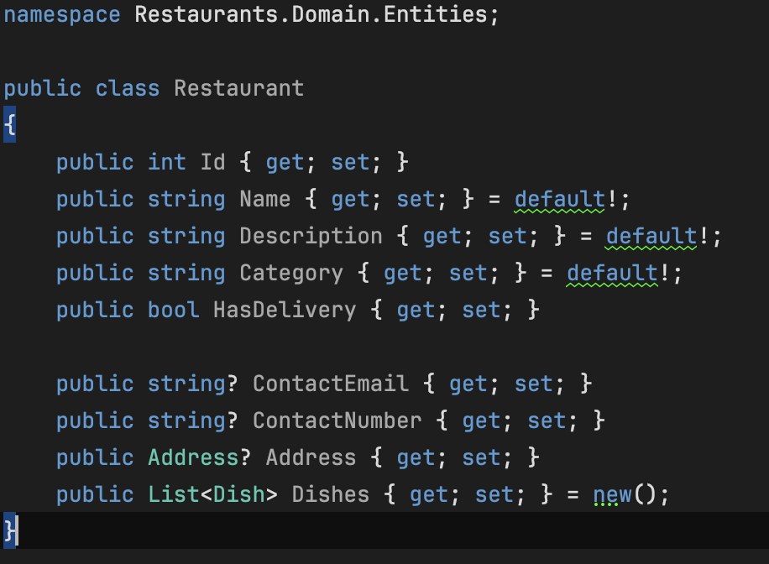

- Dish.cs
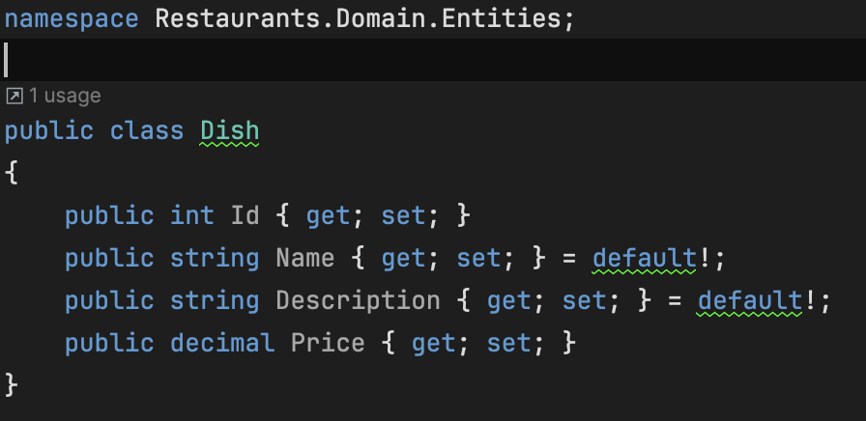

- Address.cs
